|  |
| --- |
|  |
| 新概念 3 册 |
| Lesson31 |

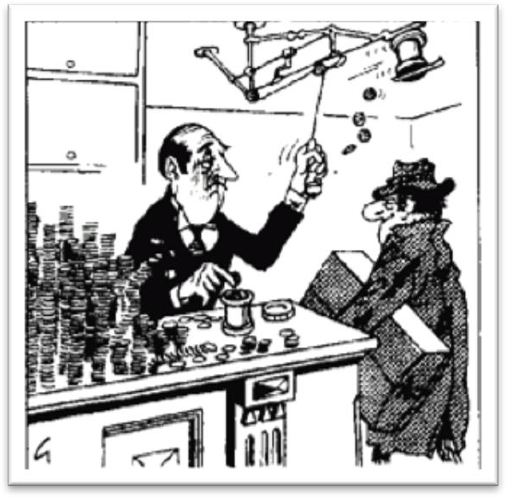Lesson 31 A lovable eccentric

**lovable ['lʌvəbl] adj.（人或动物）可爱的**lovable / loveable

a lovable eccentric / actor / dog adorable endearing winsome cute

a cute baby / puppy / kitten beloved

my beloved wife / husband

eccentric [ɪk'sentrɪk]

**n. 古怪的人；adj. 异常的，古怪的**

eccentric eccentricity

exhibit exhibition

One of his eccentricities is sleeping under the bed. freak oddball weirdo

sicko pervert

Phoebe: Oh that’s good, I guess she’ll have a choice between my guy and your weirdo. Chandler: Why would our guy be a weirdo?

Phoebe: Because that’s just your taste. Rachel: Oh my God! That's Monica!!

Joey: Oh no-no-no! No-no-no-no-no!

Rachel: You get away from me!! You sick, sick, sick, sicko!! Ross: What's going on?

Rachel: Joey has got a secret peephole! Chandler: Oh no! No! No! No!

Rachel: Yes! He has a naked picture of Monica! He takes naked pictures of us! And then he eats chicken and looks at them!

Rachel: Look!

Ross: Dude! That's my sister! Monica: Give me that!

Phoebe: All right, wait! Just wait. Everybody just calm down. Okay? Let's give our friend Joey a chance to explain why he's such a big pervert!

Joey: No! I am not a pervert! Okay?

disregard [dɪsrɪ'ɡɑ:d]

**v. 漠视，不顾，不理睬**

disregard ignore

You shouldn’t disregard / ignore safety problems.

When I saw Jane, I stopped and smiled, but she me and walked on.

[A] refused [B] ignored

[C] denied [D] missed

disregard ignore

neglect overlook

The joys of travel, having long the disabled, are opening up to virtually anyone who has the means.

[A] omitted [B] missed

[C] neglected [D] discarded pay no attention to ...

take no notice of ... turn a deaf ear to ... turn a blind eye to … **convention [kən'venʃn]**

**n. 习俗，风俗，惯例**social conventions accepted conventions international conventions

custom tradition

institution practice

On the other hand, your stomach would turn at the idea of frying potatoes in animal fat—the normally accepted practice in many northern countries.

conventional conventional values conventional lifestyle conventional measures

traditional customary

conscious ['kɒnʃəs]

**adj. 感觉到的，意识到的**

be conscious of ...

be conscious (of the fact) that ... be aware of ...

be aware (of the fact) that ... be unconscious of ...

be unconscious (of the fact) that ... be unaware of ...

be unaware (of the fact) that ... consciousness

enhance people’s consciousness of public morality

intensely [ɪn'tenslɪ] adv. 强烈地intense

intense heat / cold / pain intense love / hatred / suffering intensive

an intensive English course

two weeks of intensive negotiations intensive reading

extensive reading

labor-intensive industry capital-intensive industry technology-intensive industry knowledge-intensive industry **apologetic [əpɒlə'dʒetɪk] adj. 道歉的，表示歉意的**be apologetic about ...

He was apologetic about his late arrival. apologize apologize to sb. for sth. He apologized to me for his late arrival. apology

make an apology to sb. for sth. owe sb. an apology

say sorry to sb. for sth.

reprimand ['reprɪmɑ:nd]

**v. 训斥，批评**

reprimand rebuke reprimand / rebuke sb. for sth.

I was reprimanded / rebuked by my manager for being late.

accuse sb. of sth.

Dimitri immediately went to Aleko's house and angrily accused him of stealing the lamb.

criticize sb. for sth.

He was criticized for his delay in dealing with the matter.

censure sb. for sth.

Ministers were censured for their lack of decisiveness during the crisis.

scold sb. for sth.

His mother scolded him for breaking her favorite vase.

reproach sb. for sth.

He reproached me for not answering his letter. blame sb. for sth.

blame sth. on sb.

They blamed George for the failure. They blamed the failure on George. condemn A for / as B

The movie was condemned for its sexism.

The terrorist attack was condemned as an act of barbarism and cowardice.

stage [steɪdʒ]

**v. 组织，策划，举行，举办**

stage: organize

stage a strike / a riot / a plot / a coup / an exhibition China staged the 2008 Olympics.

deliberately on purpose intentionally

set out to do: begin a job, task, etc with a particular aim or goal 带着目的去做某事

The journalist immediately set out to obtain these important facts, but he took a long time to send them.

Dmitri at once set out to find the thief.

We never set out to hurt you, Victor. And I'm sorry we did. Are you done?

Yeah.

set out / off start out / off

Four days after setting out, while the Titanic was sailing across the icy waters of the North Atlantic, …

After making a short test flight at 4.15 a.m., Bleriot set off half an hour later. draw (one’s) attention

attract / capture / catch / arrest / command / get (one’s) attention

This attracted the attention of Richard Humphries who was then the most eminent boxer in England.

draw (one’s) attention

attract / capture / catch / arrest / command / get (one’s) attention receive (one’s) attention

This exhibition received a great deal of attention in the press, …

They disregard social conventions *without being conscious that they are doing anything extraordinary*.

without being conscious (of the fact) that … without being conscious of ...

without being aware (of the fact) that ... without being aware of ...

People tend to amass possessions, sometimes without being aware of doing so. (being) unconscious (of the fact) that ...

(being) unconscious of ...

(being) unaware (of the fact) that ... (being) unaware of ...

He used to sleep during the day and work at night, quite unaware of the fact that he had become the ghost of Endley.

They disregard social conventions, quite unconscious / unaware of the fact that they are doing anything extraordinary.

造句: 他们无视安全问题, 意识不到自己的所作所为有什么危险之处。

They disregard safety problems, without being conscious that they are doing anything dangerous. They disregard safety problems, quite unconscious / unaware of the fact that they are doing anything dangerous.

This invariably wins them *the love and respect of others*, for they add colour to the dull routine of everyday life.

invariably: always win sb. sth.

win sth. for sb.

My sincerity won me her heart. My sincerity won her heart for me. add color to sth.

Intelligent use of metaphors can add color to your writing. add luster / lustre to sth.

add flavor / spice to sth. add variety to sth.

dull boring monotonous

造句: 网上冲浪总是能赢得年轻人的痴迷(fascination), 因为它给平淡的日常生活增添了一丝亮色。

Surfing the Net invariably wins itself the fascination of the young, for it adds color to the dull routine of everyday life.

up to ... up until ...

up till ... until ...

up to ... less than ...

In Europe, taxes account for up to four-fifths of the retail price. notable

... 'the most valiant soldier and most notable leader, Signor Giovanni Haukodue'. figure

One of the most colorful figures in boxing history was Daniel Mendoza who was born in 1764. He was a shrewd and wealthy businessman, but most people in the town hardly knew anything *about this side of his life*.

“this side of his life”

➔ “his shrewdness and wealthiness”

Harry is very thrifty, but in the presence of his friends he never shows *this side of his life* (= *his thriftiness*).

He *was known* to us all *as* Dickie and his eccentricity had become legendary long before he died.

know sb./sth. as sth.

The disease is commonly known as Mad Cow Disease.

He soon made a name for himself and came to be known *to* the Italians as Giovanni Acuto.

造句：美国人把 Earvin Johnson 称为魔术师约翰逊 (Magic Johnson)。Earvin Johnson is known *to* the Americans as ‘Magic Johnson’.

造句：中国人把李白称为诗仙 (poet immortal)。Li Bai is known *to* the Chinese as ‘poet-immortal’.

Robin Hood is a legendary hero. famous / well-known

the legendary Hollywood director Steven Spielberg The Chinese are legendary for their hospitality.

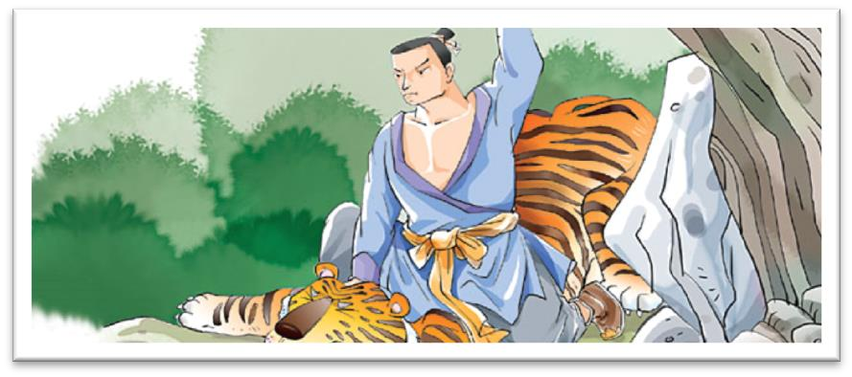造句：在上梁山前很久，武松的力量和勇敢就已经很有名了。

Wu Song’s strength and courage had become legendary long before he joined the Liangshan rebels.

Dickie hated / abhorred / detested / loathed / abominated snobs intensely. Dickie found snobs repellent / repulsive / revolting / disgusting.

Snobs repelled / repulsed / revolted / disgusted Dickie intensely.

Though he owned a large car, he hardly ever used it, *preferring always to go on foot*. hardly ever almost never

seldom rarely

prefer to do rather than do

..., preferring always to go on foot rather than go in his car.

造句：尽管他有几个保镖 (bodyguard)，但他很少让他们陪着他 (accompany him)，总是更喜欢独自一个人 (on his own) 去散步 (take a stroll)。

Though he owned several bodyguards, he hardly ever asked them to accompany him, preferring always to take a stroll on his own.

It’s raining hard / heavily. It’s pouring.

It’s raining cats and dogs.

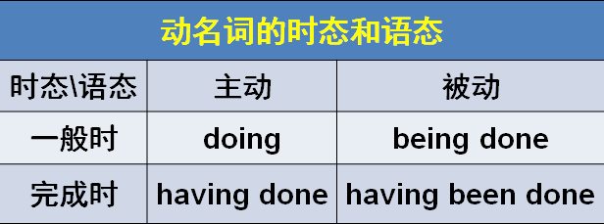

... after he had been caught in a particularly heavy shower.

be caught in ...

He was caught in a storm / traffic jam.

be struck by …

In August, she was struck by a very heavy storm during which her rudder was torn away.

He wanted to buy a £300 watch for his wife, but he was in *such* a bedraggled condition *that an assistant refused to serve him*.

金钱 + worth of + 物品

a ￡300 worth of watch

... but he was so bedraggled that ...

His family was so impoverished that he could hardly afford his tuition.

His family was in such an impoverished condition that he could hardly afford his tuition.

serve sb. with sth. serve sth. to sb.

... refused to serve him with the watch.

... refused to serve the watch to him.

Dickie left the shop without a word and returned carrying a large cloth bag. take French leave

Dumb dogs are dangerous. weigh a ton

The chair weighs a ton.

The chair is extremely heavy.

…, he dumped it on the counter. He slammed the door.

We all clapped our hands. The soldier clicked his heels.

Don’t clatter the dishes—you’ll wake the baby up.

I’ll smack your bottom if you don’t behave yourself. Dickie ignored him.

Dickie took no notice of him. Dickie turned a deaf ear to him. Dickie turned a blind eye to him.

You’re requested not to smoke here. You’re required not to smoke here.

Recognizing who the customer was, the manager was most apologetic and reprimanded the assistant severely.

When the assistant gave Dickie the watch, Dickie presented the assistant with the cloth bag. She gave a lecture on modern American poetry and was attentively listened to.

The old professor wheeled himself to the platform and was warmly applauded by the students. present sb. with sth.

present sth. to sb.

He entered the cell and presented the letter to the aristocrat. He paid me in cash / dollars.

Write it in ink / pencil / English.

动名词的逻辑主语

一般来说，动名词的逻辑主语在正式文体中用属格（所有格），在非正式文体中用普通格。在《新概念英语》和考试中，均以正式文体为准。

Do you mind *my* smoking here?（正式） Do you mind *me* smoking here?（非正式）

*Your* falling into the river was the climax of the whole trip.（正式）

*You* falling into the river was the climax of the whole trip.（非正式）

出现下列情况时，即使在正式文体中，动名词的逻辑主语也习惯使用普通格。

1、逻辑主语为名词指物。

The children are looking forward to *spring* coming. 2、逻辑主语为多个名词。

Do you remember *Mary and her mother* coming to see us last June? 3、逻辑主语为以“s”结尾的名词。

It's a disaster *the bosses* shutting all those factories. 4、逻辑主语与动名词分离。

I remember *mother* once telling us a story about the fox.

5、逻辑主语为不定代词，如：someone, everything, something; 或指示代词，如：this, that They complained about *everything* going wrong.

He disapproved of *that* being said about Mary. insist on ...

insist that ...

He insisted that the assistant (should) count the money before he left, ...

Even though the noble was expected to read the letter at each performance, he always insisted that it should be written out in full.

He always insisted on *its* being written out in full.

Next came a horse, swimming bravely, but we were afraid that the strength of the current would prevent *its* landing anywhere before it became exhausted.

This exhibition received a great deal of attention in the press, for *though the pictures were supposed to be the work of famous artists*, they had in fact been painted by Dickie.

No creature has received more praise and abuse than the common garden snail.

These young people, who love the peace of the mountains, always receive a warm welcome at St. Bernard's monastery.

the press 新闻界

the freedom of the press 新闻自由

In democratic countries any efforts to restrict the freedom of the press are rightly condemned. It took him four years to stage this elaborate joke *simply to prove that critics do not always know what they are talking about*.

... critics do not always talk sense.

... critics sometimes talk nonsense.